**GIRLS INC.** **OF OMAHA**

**MEMBERSHIP ORIENTATION**

**HANDBOOK**

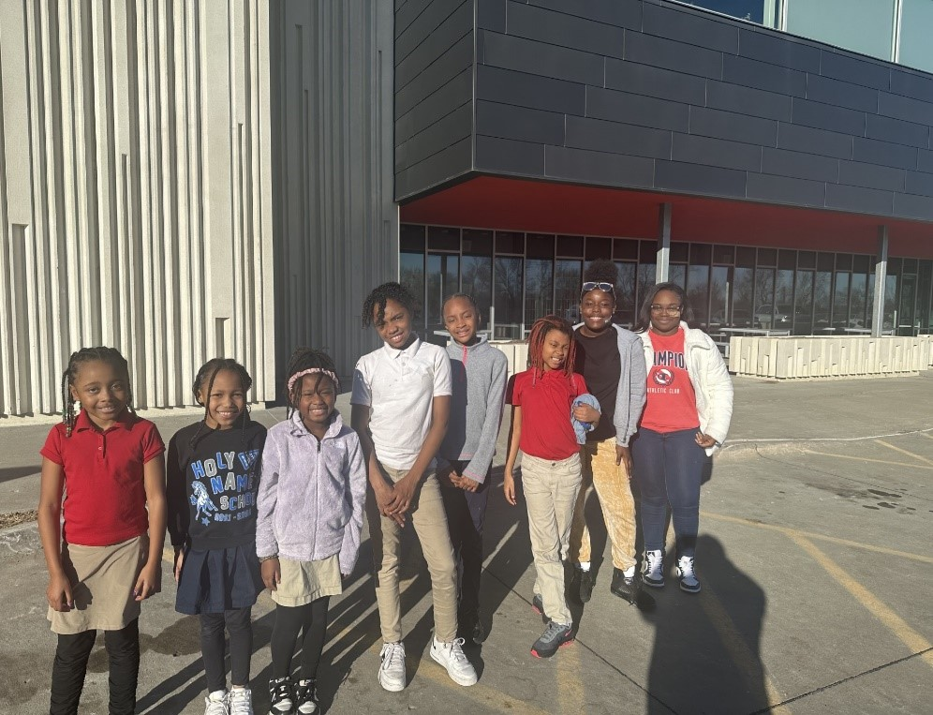

**Inspiring all girls to be strong, smart, and bold**

Updated: June 2024

C:\Users\KFCenterDir\AppData\Local\Microsoft\Windows\INetCache\Content.MSO\3017059C.tmp

C:\Users\KFCenterDir\AppData\Local\Microsoft\Windows\INetCache\Content.MSO\67CBA2F6.tmpInspiring all girls to be strong, smart, and bold.

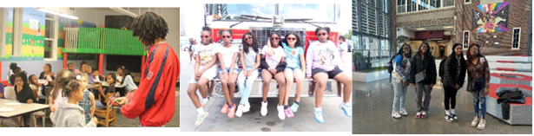

C:\Users\KFCenterDir\AppData\Local\Microsoft\Windows\INetCache\Content.MSO\382043B7.tmp

C:\Users\KFCenterDir\AppData\Local\Microsoft\Windows\INetCache\Content.MSO\6CED523A.tmpThis handbook provides important information to parents/guardians and members. We are excited to have the opportunity to serve you, and we look forward to a long and mutually beneficial relationship.

The programs and services of Girls Inc. are designed to encourage girls to try new things, build their skills and knowledge, and prepare them for a bright future. At Girls Inc., we believe that growing up is serious business, and we grow in a fun atmosphere.

Please read the contents of this handbook carefully. Feel free to consult with the Front Desk staff or the Center Director if you have any questions.

Girls Inc. is licensed as a day care by the State of Nebraska. We follow the State’s rules and regulations for the safety and well-being of all our members.

We are delighted to have you join Girls Inc. of Omaha!

**Everyday**

We provide transportation for girls who attend schools on our van/bus routes. We provide dinner during the school year; during the summer, we provide breakfast, lunch, and a light snack. We help with homework by providing paper, pencils, dictionaries, computers, encyclopedias, markers, calculators, and other tools the girls may need to get their homework done. We also provide staff, volunteers, and paid homework helpers to help with homework. We staff both of our centers with caring, nurturing adults who want the girls to succeed. We provide counseling services for girls who may need help with mental health issues, family problems, social adjustment issues, conflict resolution, etc.

**GIRLS INC. Programming**

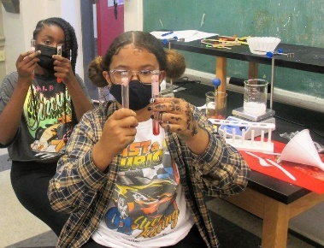During the school year, Girls Inc. offers what we consider our “core programming” between 4:45 p.m. and 5:45 p.m. each day. This is the “power hour” at Girls Inc. This is the hour that helps make your daughter smarter, safer, healthier, and more confident. It is during this hour that we provide math and science enrichment, reading instruction, dance classes, art classes, fitness activities, guest speakers, college & career prep programs, pregnancy prevention, and lifesaving HIV/STD awareness classes for our teens and more.

During the school year, we do monitor **early pick-up**. If your daughter has a doctor's appointment or an occasional reason to be picked up earlier than 5:45 p.m., we can be flexible. Just send us a written note or give us a call in advance. If you must regularly pick your daughter up before 5:45 p.m. on school days, your daughter will not be able to ride our provided transportation. **After 3 unexcused early pick ups, your daughter will lose her spot at Girls Inc.**

Some specific programs, such as Operation S.M.A.R.T.®, have limited spaces available and attendance requirements. Girls who are signed up for these programs but do not meet the attendance requirements may lose their place in the program and lose the opportunity to join other programs.

**Nutrition Schedule**

If your daughter arrives after a designated meal time, please make sure she has eaten **prior** to arrival. Do not drop her off with outside food!

* **Breakfast** – During the summer and on Fun Club Days, we serve breakfast from 8:00 a.m. to 9:00 a.m.
* **Lunch** – During the summer and on Fun Club Days, we serve lunch from 12 p.m. to 12:30 p.m.
* **Snack** – Girls receive an afternoon snack every day. During Fun Club Days, girls will receive a morning snack as well.
* **Snack-A-Licious** – On a Snack-a-licious day, girls can buy snack items and juice drinks ranging in price from 25¢ to $1. **(cash only)** Girls should not share money or snacks.
* **Dinner** - During the school year we serve dinner from 3 p.m. to 4:45 p.m.

Girls are not required to eat everything on their trays. They will, however, be encouraged to try a bite of everything and to give new foods a chance. While girls must take a milk at each meal, they are not required to drink it.

**Pathfinders Mentoring Program**

Mentoring has been critical to the success and achievement of many women. Pathfinders is a one-on-one match program where a mentor will work with a young lady until she is a senior in high school and in some cases, through college. Parents interested in enrolling their girl(s) in this program must attend an orientation. To learn more about Pathfinders, call our mentoring coordinator at 402-457-4676.

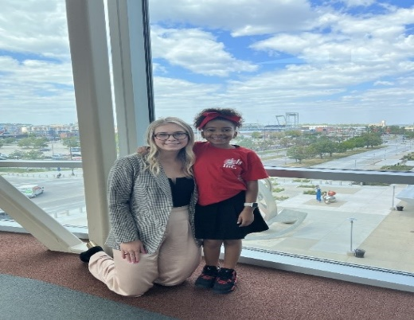

**Fun Club Days**

Hours vary. **All** parents should check with Girls Inc. annual calendar to confirm schedules for school holidays or teacher in-service days. **On Fun Club Days,** **girls can not be dropped off after 12pm.**

**Supervision**

Caring, nurturing, trained adults provide supervision during

Girls Inc. activities and programming. Teen girls, while supervised most of the time, are occasionally allowed to be on their own to work on a project, go to the restroom, type up homework, or some other sanctioned activity. Teens may be left alone, for example, for a few minutes in a teen center while a staff member steps out in the hall to have a private conversation with one girl. Girls Inc. is not the best environment for teens that require more supervision than this.

Girls Inc. is a locked facility.

C:\Users\KFCenterDir\AppData\Local\Microsoft\Windows\INetCache\Content.MSO\2994A39.tmp

**GIRLS INC. CENTERS**

* HOURS OF OPERATION

Summer and school-year program hours vary. Allannouncements, such as program hours, early closings, center closings, or other schedule changes, will be posted on the PIKMYKID app. Please make it a practice to check daily for any announcements.

**Summer Fun Club Session** 7 a.m. – 6 p.m.

**School Year Session** 2:30 p.m. – 6 p.m. on school days

**Half-Day Session** 10 a.m. -6 p.m. Half Days are the days only certain grades are out of school. For example: Only high school and Westbrook are out, so they are able to come to Girls Inc. from 10 am-6 pm. Regular hours are still in effect for all the other grade girls.

**School Fun Club Session 7 a.m.-** **6 p.m.** School Fun Club Days are when Elementary and or all of OPS is out of school. For example, February 14th OPS was out, so we had Fun Club 7am-6pm and did transportation for the schools that were still in session. Then on February 27th and 28th  we had Fun Club 7am-6pm because Elementary was out of school. We picked up High and Middle School on regular schedule.

The Front Desk is generally open at 8 a.m. during the school year and at 7 a.m. during the summer for parent/guardian inquiries and information. Please update the front desk with any/all information by 2pm.

**DROP-OFF & SIGN-IN POLICY**

For the girl’s safety, daycare licensing requires that the girls ages 5-12 years are passed directly from the supervision of one adult to another. Girl’s ages 5-12, therefore, must be escorted into the building by an adult. Once in the building, **all** girls are required to sign-in with the front desk.

Any members that will be walking to the center, must have written permission slip on file from the parent or guardian. “Walker Permission Slip”

**SIGN-OUT AND PICK-UP POLICY**

It is our policy that girls be picked up only by the people indicated on the membership application. At least two (2) adults must be listed on your approved pick-up list.

Adults picking up girls from our centers may be asked to show photo or agency ID. Girls will not be released to anyone under the age of 18. While we make every reasonable effort to comply with this policy, at times it is impossible for us to monitor all pick-ups. Before leaving the building, **all** girls are required to be signed-out/dismissed.

If you would like someone that is not on the membership application to pick your child up, **YOU** must login to the Girls Inc. portal and add the name of that person. If you want to add someone to pick your girl up just this one time, you will have to go into the PIKMYKID app and add them to your delegation list.

If your child is not picked up by closing time, we will first call you and then call those on your approved pick-up list. If we are unable to reach anyone and/or secure a ride home for the girl, it is our policy to call the police. We do not like to do this as it is obviously traumatic for the girl. Please make every effort to pick your daughter up by the scheduled closing time.

* Any members that will be walking home from the centers must have written permission on file from the parent or guardian. For those girls who attend the Katherine Fletcher Center in North Omaha, Girls Inc. does not recommend letting your child walk to and from the Centers for safety reasons.

At the Emma Lozier Center in South Omaha, transportation for Southside Terrace residents will be provided during extreme weather and during the short days of the winter months.

**Parking**

**At the Katherine Fletcher Center in North Omaha:** Please use the parking lot located on Corby Street. For additional parking, feel free to use 45th Street on the west side of the building. Do not park on the north side of Corby Street.

**South Omaha Emma Lozier Center:** Parking is prohibited in front of the Girls Inc. garage. Please use the lot located across the street from the center.

**Transportation**

Transportation is a privilege. Girls who do not follow transportation rules and etiquette may lose transportation privileges.

For Safety reasons, girls are not allowed off transportation before reaching their destination and non-staff/volunteers are not allowed to board transportation.

*Please help us save on our gas budget!* If our transportation stops at a designated school and no girl’s board, staff are instructed to discontinue stopping at that school until further notice. It is a parent or guardian’s responsibility to call the school if your daughter does not need to be picked up from school, so they won’t send your girl out to our vehicle for pick up. **Due to our long list of school pick-ups staff will only wait 5 minutes outside of each school. Please encourage your girl to get to the Girls Inc. bus/van as soon as school is over, they will get left!**

**Teaching Appropriate Behaviors**

Girls Inc. staff deal with minor behavioral issues internally without interrupting the parent at work by calling about every issue that arises. If Behavioral issues persist, they will be logged, and parents will be contacted. Girls may receive a counseling referral.

**Permission Slip Policy**

Additional permission slips may be required for participation in special programs, activities, or field trips; as well as for program evaluation purposes.

**Pre-Membership Visit**

Girls may attend one time as a visitor during regular after-school or summer programming. The parent/guardian of a visiting girl must provide, in writing, emergency contact information and pick-up information on the day of her visit.  Visitors must sign in at the Front Desk. Visitors do not attend field trips.

**EXPECTATIONS OF ADULTS AT GIRLS INC.**

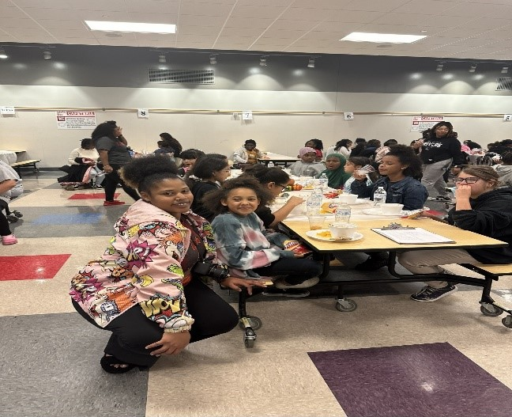All grownups in our centers – staff, mentors, volunteers, parents, guardians, and program partners:

* Do not curse at each other.
* Do not threaten or intimidate each other.
* Do not raise our voices.
* Serve as role models to the girls by demonstrating anger management, impulse control, patience, tolerance, and understanding.
* Speak respectfully to each other.
* Follow Girls Inc. policies and procedures.
* Give each other grace or the benefit of the doubt – we all want what is best for the girls.

**PIKMYKID APP**

GIO Parents/Guardians,

This is Girls Inc. New Dismissal App…

Please go download the **PIKMYKID App,** which can be found in your play store on your phone for free.

Click on **create account** using your email address. You will receive a code, please use that code in the space provided. **Make sure you verify your email when it prompts you to do so.**

Once you have verified your email, go back into the **PIKMYKID App and login in.** You will use your email address and phone number to do so.

You should see your name at the top, Girls Inc., your girl(s) name, which car line you are assigned to, the grade, and student ID #.

At the bottom of the app, you will see an icon labeled Pick Up. When you arrive on campus, please click that icon and click the announce tab. This will notify the staff that you are outside in the car line for pick up.

Please keep the front desk updated with any new information before 2 pm each day. You can also add anyone to your contacts in this app that you would like to be able to pick your girl(s) up.

**Emergencies Closings**

In cases of extreme weather conditions or other emergencies, Girls Inc. may deem it necessary to close early or not provide transportation to our Centers. Girls Inc. follows the Omaha Public School guidelines for extreme weather; if OPS is closed, Girls Inc. will be closed.

Parents/Guardians must complete the weather/emergency cancellation procedure form in the Membership Application. This form lists instructions for your girl in the event Girls Inc. is closed due to weather or other emergencies even though school is not cancelled. Be sure your girl’s know what to do in this situation. We share your completed forms with the schools so they will know, too.

If bad weather occurs during programming hours, emergency procedures will be followed based on the weather condition. During a tornado warning, girls will remain in designated areas of the building. We strongly discourage parents from removing girls from shelter during tornado warnings. Parents are welcome to take shelter in the building with the girls and staff during storm warnings. During a tornado warning, all staff will take cover in the parking garage along with the girls. The front desk will not be covered and you may not be able to enter the facility. At the Katherine Fletcher Center, there will be access to the FEMA-rated storm shelter in the parking garage through a door on the north east corner of the building.

* **Contact Information**

Parents/Guardians must keep address, phone, and other contact information updated at all times. A new membership application must be filled out annually. It is the parent/ guardian’s responsibility to provide us with at least one reliable person to contact in case of an emergency. More than one person may be listed. You will need to come to the Front Desk in person to update this information or make any additions or changes.

* **Fire & Tornado Drills**

Each Center will have periodic drills so everyone is prepared for emergencies.

**Late Fees**

Girls must be picked up by closing time. Parents/Guardians picking up a girl after closing will be assessed a fee of **$3 for every minute late.** If late fees are not paid within two weeks, your girl will no longer be able to attend our Center, and a meeting between the parent/guardian and the Director of Operations will be required to reinstate their privileges.

**Membership Fees**

Girls Inc. membership is **$100** for 5-12 year olds for any portion of a calendar year. Our calendar year runs from August to August. Teens are paid by the organization, which makes it **FREE** for you. Your fees cover a small portion of programming, transportation, and meal costs. The remaining costs are paid for through the generosity of community donors, corporations, and foundations. **Membership fees are not refundable.**

* **Field Trip Fees**

Many field trips are provided at no charge to the girls, while a few require a paid fee for admission. If a girl is denied access to a paid field trip due to behavioral issues, no refunds are issued. If the field trip is canceled, fees will be refunded. Fees may also be charged for girls who have signed up for a field trip, especially on the weekend, or an educational camp, and do not show up.

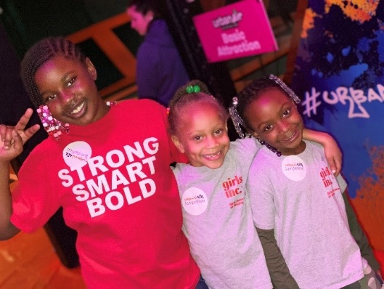

* **CLOTHING & PERSONAL PROPERTY**

**For both safety and programming reasons, girls must wear tennis shoes/crocs w/ a strap attached to Girls Inc.** **during the summer programming. Open-toe shoes/flip-flops, Spaghetti Straps, or shorts/skirts shorter than the fingertip are not allowed.** Some activities, such as art classes, gardening, and cooking classes, are messy. Clothes should be comfortable and allow for physical movement. Members dropped off at the Center wearing inappropriate clothing will be required to be picked up from the Center.

Girls **must** leave valuables (including but not limited to Tablets, Cell phones, headphones, etc.) at home. Because many of the girls have identical coats, jackets, backpacks, etc, it is important that personal items are clearly marked. **Girls Inc. is** **not responsible for lost or missing items.** Girls under 13 are not allowed to bring purses. Tampons and sanitary napkins are available at

The Front Desk.

* **HEALTH & MEDICATION**

Girls with a significant temperature, open sores, ringworm, impetigo, or any other contagious disease will be sent home. Parents/Guardians will be contacted immediately. A doctor’s note will be required for a member to return to Girls Inc. Keep girls at home when they are ill.

Parents/Guardians must sign a competency form that gives Girls Inc. staff consent to administer/oversee the use of medication. Any member requiring medication must check it in at the Front Desk. All medications must be sealed in a Ziploc baggie clearly marked with the girl’s name, and include:

* The medication is in its original container
* Any additional item necessary to administer the medication
* Written instructions for use signed by a parent/guardian including date(s) and time(s) for the girl to self-administer the medication

*An Asthma Action Plan* is required, and an on-site inhaler is required for girls who have asthma.

**LICE:** In order to keep the Centers cleared of lice, from time to time, Girls Inc. staff may do head checks. Girls with lice will be sent home for treatment.

* **RESTROOM BREAKS**

We do not have staff to accommodate individual trips to the restroom. We take group restroom breaks every hour to an hour and a half. While we will attempt to accommodate individual emergency situations, for enrollment purposes, we accept girls for whom our restroom break schedule is not a hardship.

* **CELL PHONES**

Girls Inc. is a cell phone/electronics free facility. All girls are required to turn their phones in at the front desk until they are picked up. Girls in the teen center can, however, have their phones but must put them away during programming. The girls can not record or be on any social media sites while at Girls Inc. That includes TikTok, Facebook, Instagram, etc…

* **INSURANCE**

All girls have Secondary Accident Insurance while participating in Girls Inc. activities. The cost for this is included in the membership fee. Katherine Fletcher Center 2811 N. 45TH Street, 402-457-4676.

**PARENT/GUARDIAN POLICIES & PROCEDURES**

The Girls Inc. staff is open to hearing any of your concerns and is here to answer any questions you may have about our policies and procedures. Our staff will be professional and respectful when addressing your concerns, and we ask parents and guardians to respect staff in return.

**NOTICES, ANNOUNCEMENTS & INFORMATION**

*At the North Omaha Katherine Fletcher Center:* All Important announcements such as closings, our calendar, the PIKMYKID app, Activity fees, field trip permission slips, consent forms for surveys, etc., are posted on the Parent Board across from the Front Desk.

*At the South Omaha Emma Lozier Center:* All Important Information, announcements, and permission slips are posted on the Table in front of the Front Desk.

* **ORIENTATION**

In order to become a member of Girls Inc., a parent/guardian must attend a yearly orientation session. Enrollment applications of 6-year-olds must be accompanied by a birth certificate. Girls Inc. will make a copy of the birth certificate for our records.

* **STAFF MEMBER CONCERNS**

If you have a concern about one of our staff members, ask to speak with the Center Director, Director of Operations, or Executive Director.

* **VOLUNTEERS**

Parents/Guardians, grandparents, and other interested adults are encouraged to get involved in Girls Inc. programs. Volunteers are needed to assist with homework activities, serving meals, field trips, job shadowing, programming, and more. For more information, contact the Front Desk, Volunteer Coordinator, or Director of Operations. All volunteers will be background checked before being in the presence of the girls.

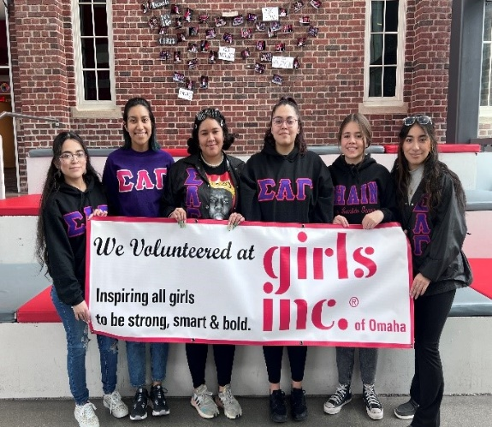

C:\Users\KFCenterDir\AppData\Local\Microsoft\Windows\INetCache\Content.MSO\395F0A55.tmp

Parents/Guardians are required to fully complete the PARENT / GUARDIAN CONSENT & AGREEMENT section of the Membership Application Form. Consent items include but are not limited to:

* Consent to access your child’s school records
* Consent to obtain your child’s Immunization Records
* Consent for emergency medical treatment
* Release of Girls Inc. from any and all claims or causes of action
* Consent for your child to ride on Girls Inc. busses or vans
* Consent for your child to participate in evaluation activities.
* Consent to use your child’s name, photograph or video/film image
* Consent for your child to participate in age appropriate classes and workshops
* Consent for your child to participate in field trips
* Agreement to review member rules with your child
* Consent for your child to have access to reproductive health educational programs and access to reproductive health services

C:\Users\KFCenterDir\AppData\Local\Microsoft\Windows\INetCache\Content.MSO\6A8A82EE.tmp

***Please read this section with your daughter.*** Girls Inc. strives to offer a safe and positive environment. It is essential that members follow the Girls Inc. rules and the direction of staff at all times. Disciplinary action, up to and including cancellation of membership, will be taken for inappropriate behavior.

**CENTER RULES**

* Be respectful of yourself, other girls, staff, and visitors.
* Be respectful of the Girls Inc. property and building. (Girls and/or parents/ guardians will be required to pay for willful damage to any Girls Inc. property.)
* Be safe and let staff know of any unsafe activities.
* Girls may not bring in outside food or drink (this includes gum).
* If you have an issue with another member, tell a staff person.

**TRANSPORTATION**

Girls Inc. transportation is a privilege. Girls that do not follow bus and van guidelines may lose transportation privileges.

* Use a soft voice in the bus or van.
* Follow directions.
* Be respectful of other girls, transportation staff, and the driver.
* Wear a seatbelt in the van and remain seated and belted-in until the van comes to a complete stop.
* Only get off transportation at your designated stop or when told by staff

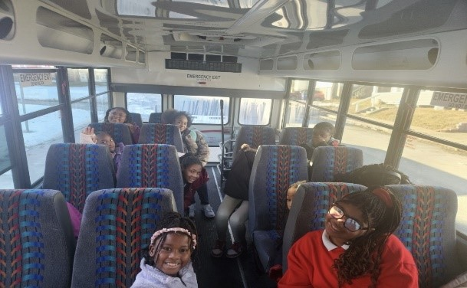

**OTHER RULES**

There are special rules for specific programs and areas of the facility. Rules will be reviewed with the girls.

**Gym:** Shoes and Socks must be worn at all times unless Gymnastics is taking place. No running or lying down on the bleachers. No Food or Drinks are allowed in the gym at any time. Balls are not to be kicked or thrown at anyone. We do not allow the girls to do flips, death drops, pop-ups, or handstands anywhere in the building.

**Fitness Center:** A staff member must be present at all times when girls are occupying this area. 6th grade and under are not allowed in the fitness center at all. There is no running or horseplay allowed. Keep music at a reasonable volume. No food or drinks are allowed at any time.

**Computer Lab:** Girls are not allowed on any social media sites or games with chat rooms. No food or drinks are allowed in this room at any time.

**Teaching Kitchen:** All girls need to be accompanied by an Adult to operate anything in the kitchen. All dishes and supplies must be cleaned and put away once programming is complete. At no time are the girls allowed to get or have ICE.

**Media Center:** An adult must be present with any girls in this room. No food or drinks are allowed at any time. Girls are not allowed on any social media sites or games with chat rooms.

**Field Trips:** Girls must wear a Girls Inc. shirt provided by us. No phones are allowed. No outside food is allowed. Only with permission can a girl bring money. All girls must follow rules and stay with the adult and group at all times.

**Discipline Policy and Procedure**

* Policy

We take every effort to manage behaviors in the classroom setting by using our guidance strategies. Guidance strategies include but are not limited to positive redirection or role modeling, positive reinforcement

change of scenery, teaching moments, time out, and giving the member options.

* Procedure

When a member negatively affects the classroom environment, she will be asked to leave the classroom and go to the Girl Hub/Center Director Office where the director will assess the needs of the member. The behavior will be logged at the front desk and if deemed necessary, a written behavior notice will need to be signed by the parent/guardian in a timely manner to discuss the situation.

Release of Care

* Policy

**Safety:** At Girls Inc. we strive to provide an environment that is both physically and emotionally safe for both members, staff, program partners, and volunteers. We reserve the right to terminate the enrollment of a member at any given time due to behavior that impacts the safety of others.

**Learning:** At Girls Inc., we strive to provide a positive environment where girls can learn in a hands-on, minds-on space. We reserve the right to terminate the enrollment of a member due to consistent behaviors that prevent other members from learning.

* Procedure

There will be three written behavior warnings issued by a member of the Girls Inc. staff team and signed by the parent/guardian. After the third warning, the member’s enrollment may be terminated. Please understand there will be cases where some behaviors are deemed to be a severe safety risk and, therefore, the member may be asked to leave the program immediately.

Girls Inc. staff may request a counseling referral to assist with behavioral concerns. Parents may also request a counseling referral.

A one-week notice will be granted for the parent/guardian to find an alternate placement unless an immediate dismissal is necessary for safety purposes. After one week, Girls Inc. membership will be discontinued. After six months, the member may return for a trial reinstatement at the Center Director’s discretion.

C:\Users\KFCenterDir\AppData\Local\Microsoft\Windows\INetCache\Content.MSO\AD5FD7DE.tmp

C:\Users\KFCenterDir\AppData\Local\Microsoft\Windows\INetCache\Content.MSO\1082AF9C.tmp

 Visit our website ([www.girlsincomaha.org](http://www.girlsincomaha.org/)) to learn about our events, read our most recent news releases, or download documents such as the Girls Inc. membership application or a copy of this Membership Handbook.

The Girls Inc. Gossip Blog features photos, quotes, and video clips from girls, staff, program partners, and volunteers.

C:\Users\KFCenterDir\AppData\Local\Microsoft\Windows\INetCache\Content.MSO\89D208A8.tmp

 “Like” the Girls Inc. of Omaha page on Facebook. Facebook provides an opportunity for our fans to participate in a virtual community of support for Girls Inc. Learn more about day-to-day programs, see pictures of the girls, leave comments, and hit the “Like” button if you like what you see.

C:\Users\KFCenterDir\AppData\Local\Microsoft\Windows\INetCache\Content.MSO\739D7CF6.tmp

Follow Girls Inc. of Omaha on Twitter (@GirlsIncOmaha). Twitter offers on-the- spot information about daily programs such as basketball game scores or party events. It also provides links to articles and information about girls, gender equity, political advocacy, and more.

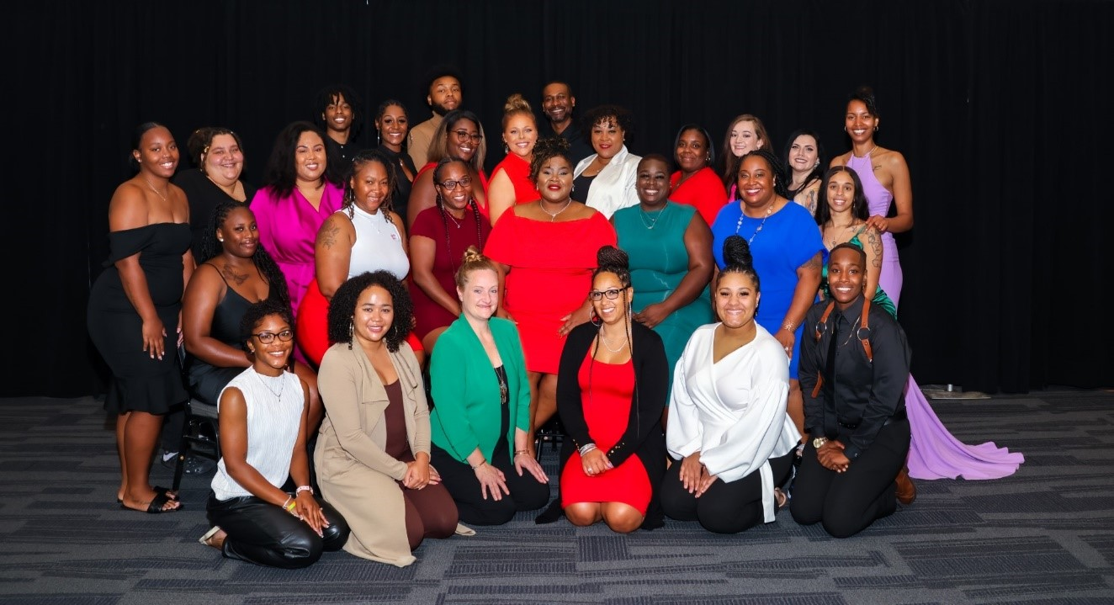

**GIRLS INC. OF OMAHA LOCATIONS:**

**KATHERINE FLETCHER** **EMMA LOZIER CENTER**

**CENTER**

2811 NORTH 45TH ST. 5407 SOUTH 30TH ST.

OMAHA, NE 68104 OMAHA, NE 68107

(402) 457-4676 (402) 731-2108

FOR MORE INFORMATION, CONTACT:

Candias Jones

Executive Director

[cjones@girlsincomaha.org](mailto:cjones@girlsincomaha.org)

402-457-4676

Tracy Brown

Director of Operations

[tbrown@girlsincomaha.org](mailto:tbrown@girlsincomaha.org)

402-457-4676

Annetta Owens-Cooper Joselyn Gonzalez

Katherine Fletcher Center Director Emma Lozier Center Director

[aowens@girlsincomaha.org](mailto:aowens@girlsincomaha.org) [jgonzalez@girlsincomaha.org](mailto:jgonzalez@girlsincomaha.org)

402-457-4676 402-731-2108

C:\Users\KFCenterDir\AppData\Local\Microsoft\Windows\INetCache\Content.MSO\88D82479.tmp

C:\Users\KFCenterDir\AppData\Local\Microsoft\Windows\INetCache\Content.MSO\D021A4D5.tmp

C:\Users\KFCenterDir\AppData\Local\Microsoft\Windows\INetCache\Content.MSO\AF23C2AB.tmpI attended an annual orientation for Girls Inc. Membership policies and procedures were reviewed with me by a member of the staff team and I had a chance to have my questions answered.

I understand that by signing this form I agree to the policies and procedures for my member to attend.

 Received a copy of the handbook in person

     Print Name of Member: **_______________________________________________**

C:\Users\KFCenterDir\AppData\Local\Microsoft\Windows\INetCache\Content.MSO\6B125CF1.tmp

     Print Name of parent/guardian:

**____________________________________________**

Signature of parent/guardian:

C:\Users\KFCenterDir\AppData\Local\Microsoft\Windows\INetCache\Content.MSO\44575D27.tmpC:\Users\KFCenterDir\AppData\Local\Microsoft\Windows\INetCache\Content.MSO\64C7E8CD.tmp

Name Date

Name of Orientation Staff:

C:\Users\KFCenterDir\AppData\Local\Microsoft\Windows\INetCache\Content.MSO\B793C163.tmpC:\Users\KFCenterDir\AppData\Local\Microsoft\Windows\INetCache\Content.MSO\7CCBA469.tmp

Name Date